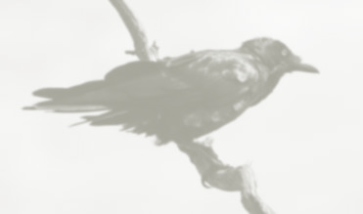
Blackbird’s Newsletter Spring 2022

Dear Parents and Carers,
I would like to take this opportunity to welcome you all back to school and wish you and your families a Happy New Year. I hope you were able to have the best Christmas possible for you and that Covid did not impact your plans too much. I would also like to once again thank you for your very generous gifts and cards, they were very much appreciated.
During this term the learning will focus around our topic of ‘Epping Forest’. Blackbirds will be doing a variety of cross curricular work on the subject area, including our new class reading book ‘Letters From the Lighthouse’.
Throughout the topic we will be researching many different aspects of Epping and will link it into our History topic of Local History. We will research who and what impacted the development of Epping, including; Queen Victoria and the Lopping Rights, Winston Churchill and WWII
In English, we will continue to develop our different writing skills, focussing on grammar and punctuation. We will be writing biographies, newspaper reports, instruction writing and looking at performance poetry. Spellings will be worked upon within school and the children will also have their weekly reading challenges to complete at home.
Daily Maths lessons will take place in the morning and continue to build on the children’s previous knowledge. We will be covering area and perimeter, decimals and percentages, fractions and continued daily arithmetic. As always there will still be a focus on times tables, not all children are fluent in these and it would be extremely beneficial if they could be practised at home on a regular basis.
RE this term will be about beliefs and practices of different religions and their celebrations.
In Science the topics we will be learning about are ‘Living Things and Their Habitats’ and ‘Changes in Materials’. This will include learning about life-cycles of both animals and plants, why we use certain materials and how this impacts society.
Geography will be a combination of ordnance map work, compass work and the physical and human features of Epping and how it has evolved.
Computing will be looking at Flat file databases and video editing.
Art and DT will be linked to both the history topic and our focus text (Letters From The Lighthouse). We will be creating 3D clay tiles, still life sketches and creating art in the style of Seurat-pointillism.
PE will concentrate on netball, dance and athletics, including regular sessions from Tom. Our PE days are Tuesday and Friday. Children should come into school in their PE kit on these days.
Music this term will be investigating rhythms and using musical instruments to create a soundtrack for our focus text.
Within French this term we will be learning about numbers, telling the time and food and drink.
RSE will be concentrating on happy and healthy relationships, similarities and differences and we will continue to focus on Mindfulness and good Mental Health.
I look forward to a productive and happy term - if you have any concerns or questions, please do not hesitate to email me on lbaker@eppingupland.essex.sch.uk .
Thank you for your support and cooperation
Lisa Baker

